

24ADC001- BUSINESS INTELLIGENCE

--------------------------------------------------

2026-2027
LAB RECORD

DEPARTMENT OF ARTIFICIAL INTELLIGENCE AND DATA SCIENCE

INDEX
Expt. No | Title of the Experiment | Page No | Total Marks | Faculty Signature
1. | Explore the interface and basic features of the BI tool
2. | Load and visualize a sample dataset.
3. | Import a dataset into the BI tool. And Cleanse data by handling missing values, outliers, and  inconsistencies.
4. | Transform data to suit BI reporting requirements and Design a dashboard with  key performance indicators (KPIs).
5. | Develop interactive dashboards for dynamic data exploration.
6. | Integrate data from various sources for comprehensive analysis
7. | Implement advanced chart types (treemaps, heatmaps, etc.).
8. | Apply BI tools for forecasting and predictive analytics.

Average marks Faculty Signature

NAME : GOWTHAM S
ROLL NO : 24BAD028

EXPT NO:1 | EXPLORE THE INTERFACE AND BASIC FEATURES OF BI Tool
DATE: 10.07.2026

PRE-LAB QUESTIONS

- What is the purpose of Business Intelligence (BI) tools like Tableau and Power BI?
Business Intelligence tools like Tableau and Power BI analyze, visualize, and present data through dashboards, helping users identify trends, gain insights, and make informed business decisions.

- List any three common data sources that Tableau and Power BI can connect to.
Tableau and Power BI commonly connect to Microsoft Excel, CSV files, and SQL databases, allowing users to import, analyze, and visualize data efficiently.

- What is a dashboard in BI, and how is it different from a single chart?
A dashboard combines multiple charts, KPIs, and filters into one interactive view, while a single chart displays only one aspect of the data.

- Define the following terms:
  - Visualization : Graphical representation of data using charts, graphs, or maps to simplify analysis and improve understanding.
  - KPI : A Key Performance Indicator measures progress toward business objectives using quantifiable performance metrics.
  - Data Filter : A feature that displays only selected data based on specified conditions, improving focused analysis.

- Why is it important to clean and transform data before visualization?
Cleaning and transforming data removes errors, duplicates, and missing values, ensuring accurate analysis, reliable visualizations, improved data quality, and better business decision-making.

- What kind of chart would you use to analyze stock price trends over time?
A line chart is ideal for analyzing stock price trends over time because it clearly shows continuous changes, patterns, and market movements.

- Explain the role of slicers in Power BI and filters in Tableau.
Slicers in Power BI and filters in Tableau allow users to interactively display only relevant data, making dashboards easier to explore and analyze.

- What does a calculated field or measure do in BI tools?
A calculated field or measure performs mathematical calculations on existing data, creating new values like totals, averages, percentages, or custom business metrics.

- What are the advantages of using interactive dashboards for financial data analysis?
Interactive dashboards provide real-time insights, simplify financial analysis, enable filtering and drill-down, improve decision-making, save time, and present complex financial information visually.

- Which function would you use to find the absolute difference between predicted and actual stock prices?
The ABS() function calculates the absolute difference between predicted and actual stock prices, returning a positive value regardless of whether the difference is negative.

IN-LAB EXERCISE:
Objective:
To understand the basic interface, data import process, and fundamental visualization capabilities of Tableau and Power BI using a stock prediction dataset, and to explore their usefulness in analyzing financial data.

Tools Required:
- Tableau Public / Tableau Desktop
- Power BI Desktop
- Sample Dataset (CSV/Excel) containing:
Date, Stock Name, Open, Close, High, Low, Volume, Predicted Price

Exercise Steps:
Part 1: Working with Tableau
- Launch Tableau and connect to the stock prediction dataset.

Explore the Interface:
  - Understand components like Data Pane, Sheets, Marks Card, and Dashboards.

Create Basic Visualizations:
  - Line Chart: Show Close Price over time.
  - Scatter Plot: Plot Volume vs. Predicted Price.
  - Highlight Table: Display Predicted Price by stock.

Apply Filters:
  - Add filters for Stock Name and Date Range.

Create Calculated Field:
  - Calculate prediction error as |Predicted - Close|.

Design a Basic Dashboard:
  - Combine your charts into one interactive dashboard.

Steps Screenshot :

1.Dataset Imported
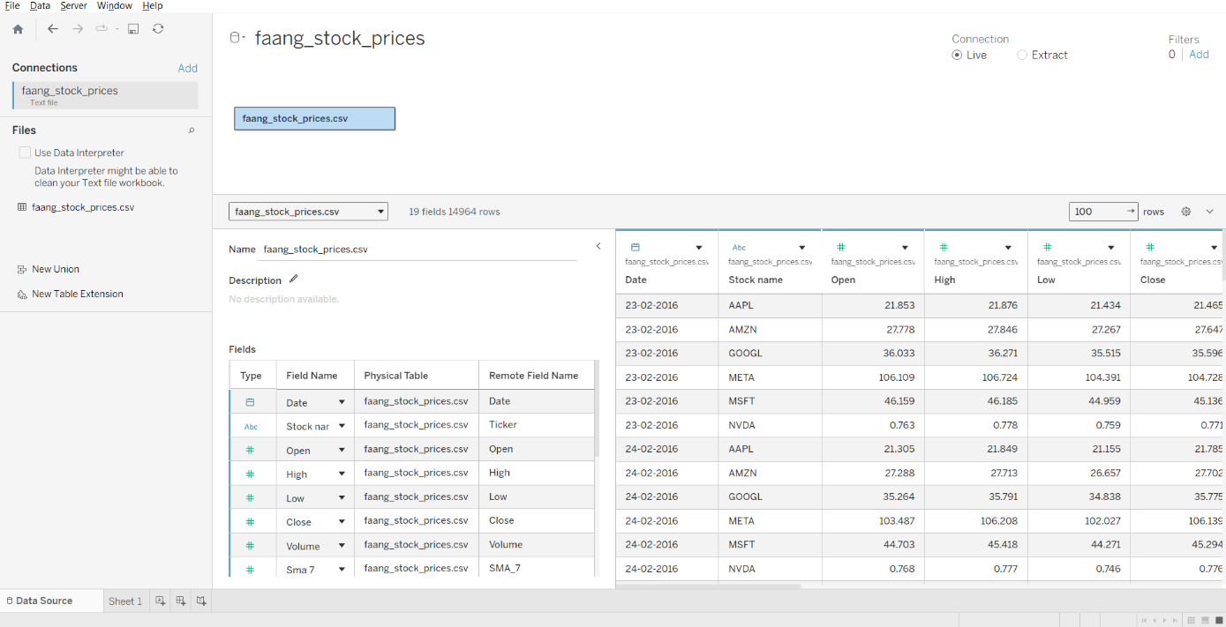

2.Tableau Interface
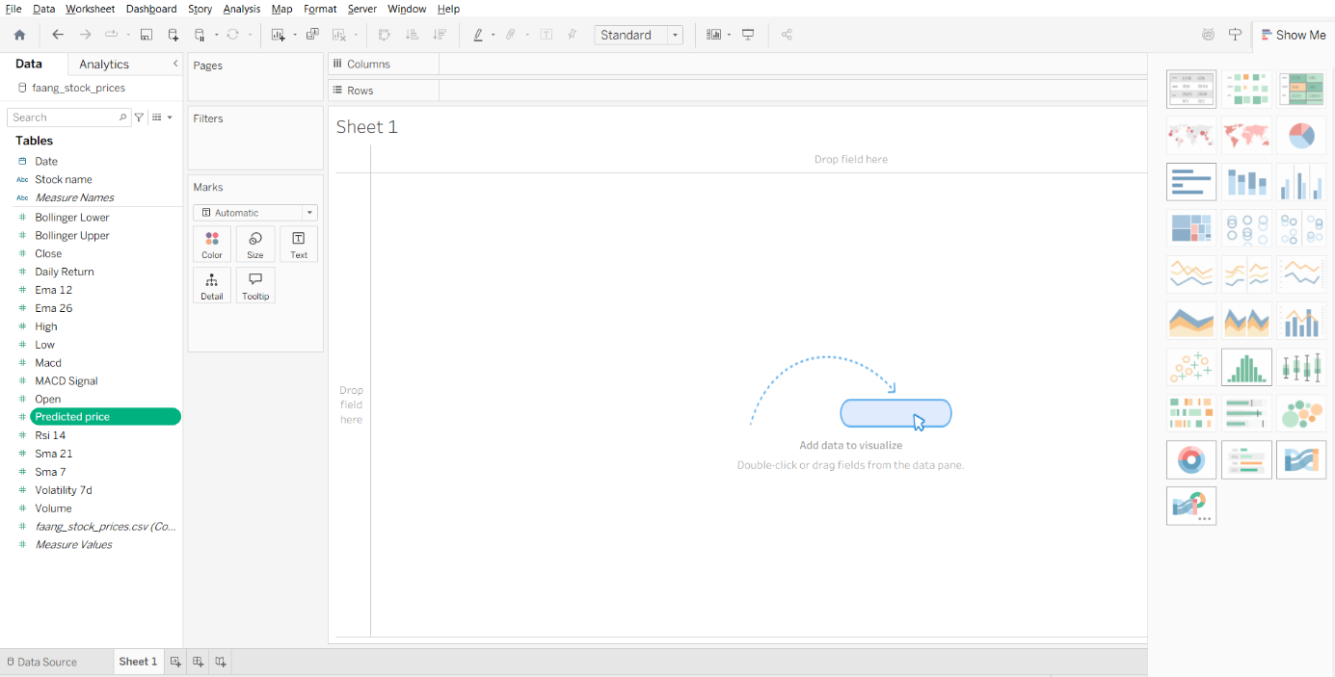

3.Basic Visualizations
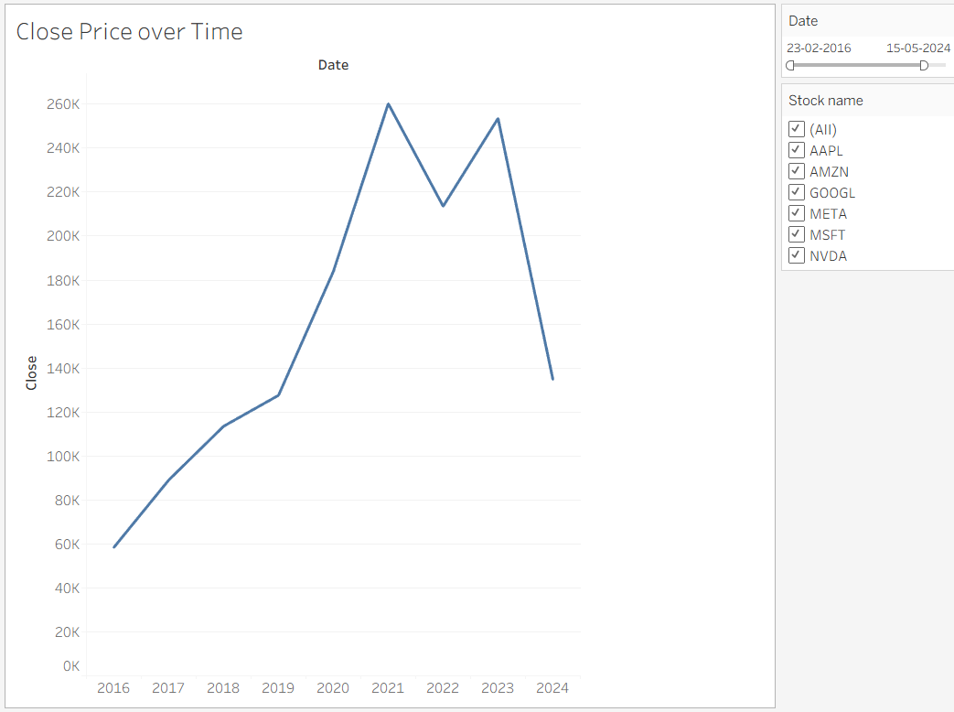
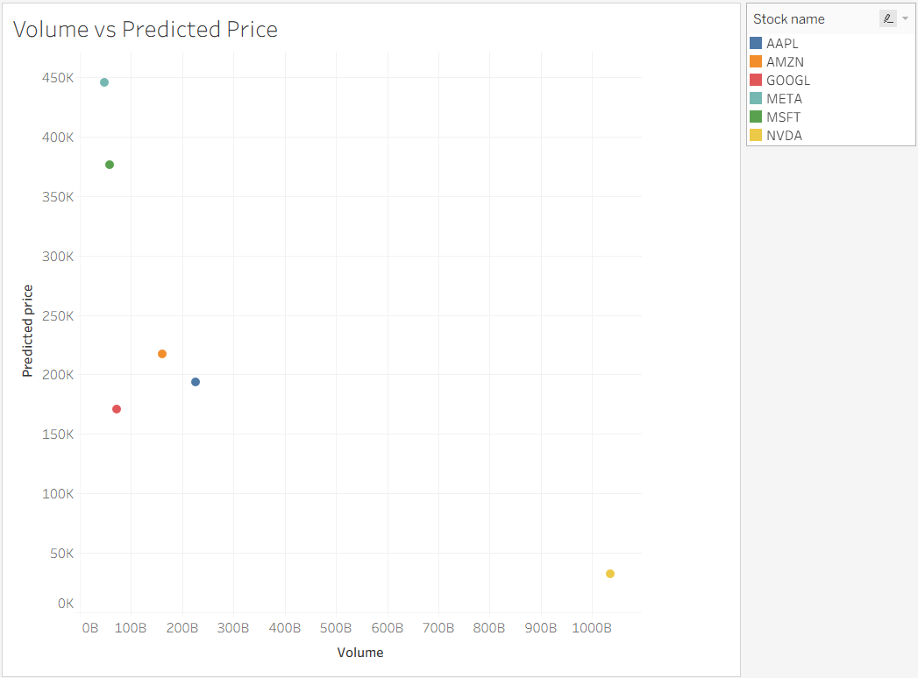
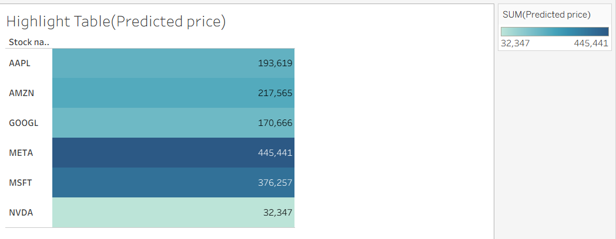

4.Calculated Field
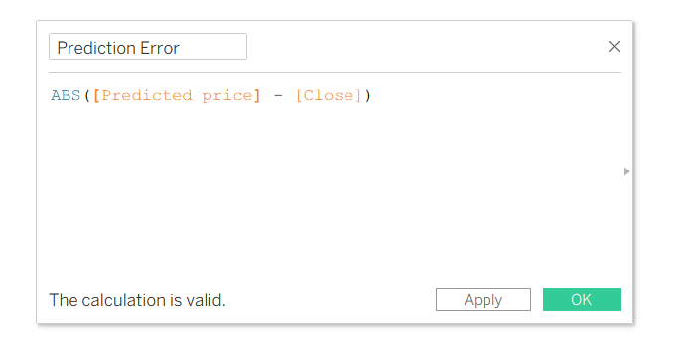

5.Final Dashboard
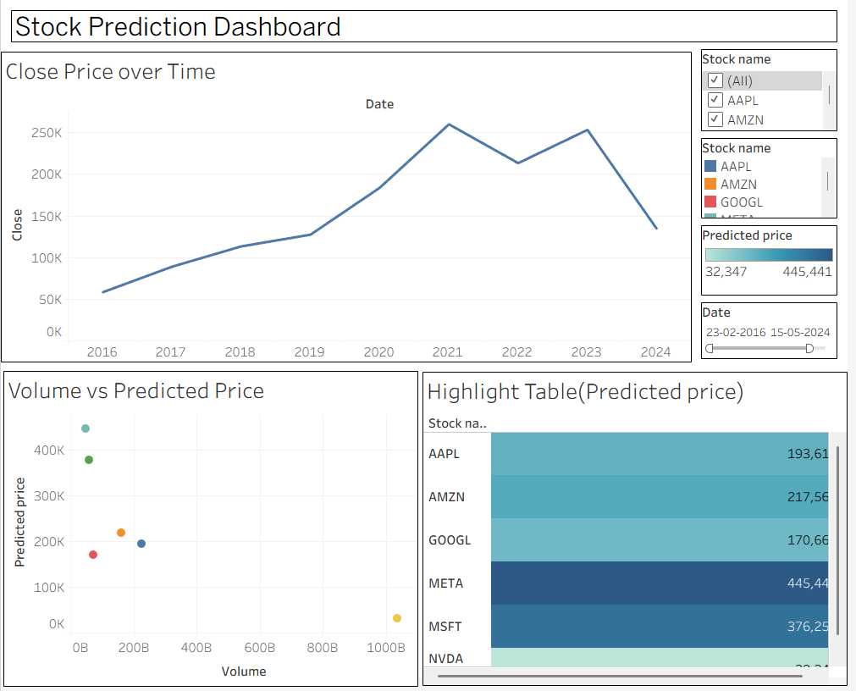

Part 2: Working with Power BI
- Open Power BI Desktop and import the same dataset.

Explore the Interface:
  - Familiarize with Fields Pane, Visualizations Pane, Report View, Data View.

Create Basic Visualizations:
  - Line Chart: Trend of Close Price over time.
  - Bar Chart: Compare Predicted Price vs. Close Price.
  - Card (KPI): Display average prediction error.

Use Filters and Slicers:
  - Filter data based on Stock Name and Date.
- Create a Simple Measure using DAX:
  - Example: Prediction Error = ABS(Predicted - Close)

Build a Report Page:
  - Arrange visuals in a single interactive page.

Steps Screenshot :

1.Dataset Imported
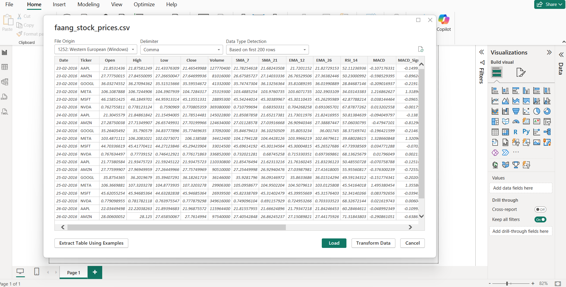

2.PowerBI Interface
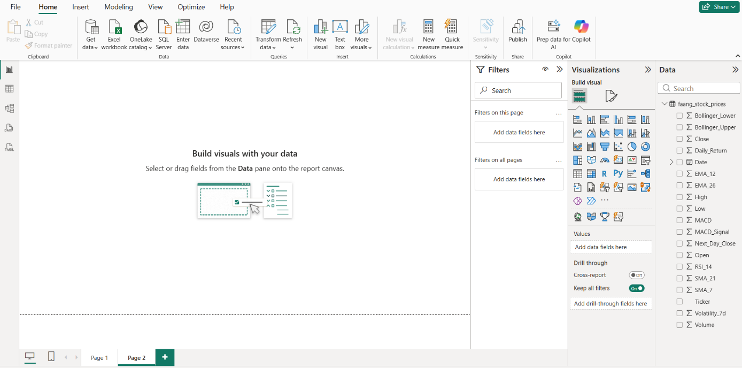

3. Basic Visualizations
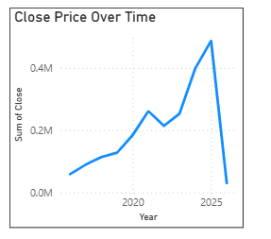

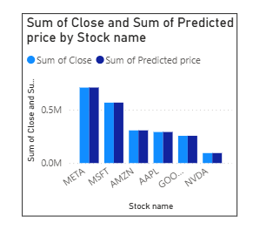

4.Calculated Field

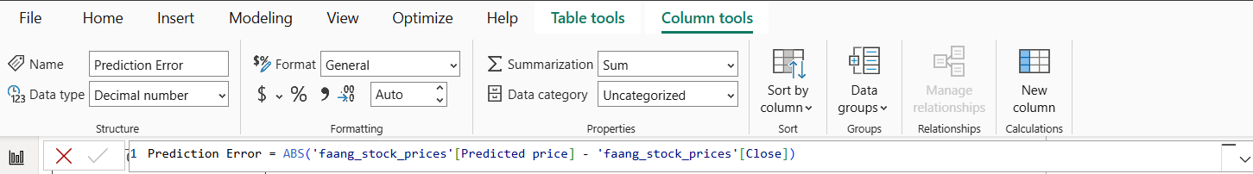

5.Final Dashboard
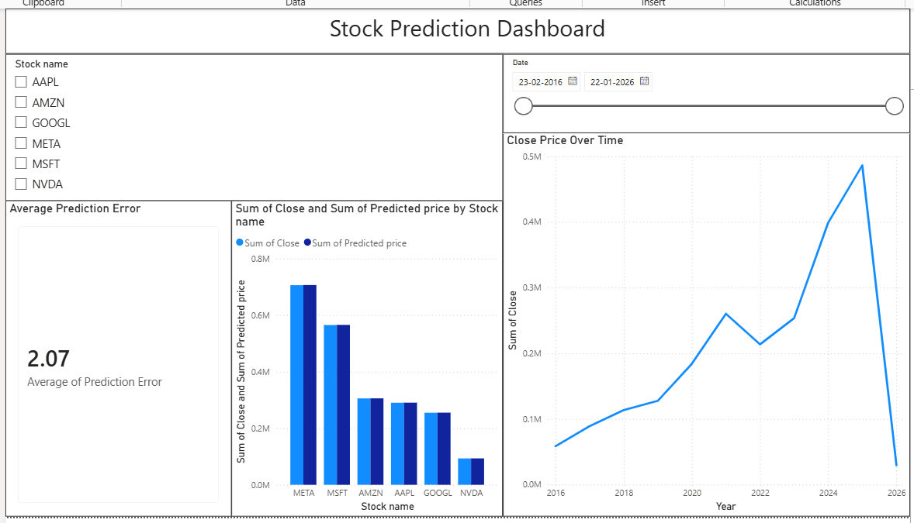

POST-LAB QUESTIONS

- Describe your experience with the Tableau interface. What components did you interact with?
I explored the Tableau interface using the Data pane, Marks card, Columns, Rows, Filters, and Dashboard tabs to create and customize visualizations effectively.

- How did you import the dataset into Tableau and Power BI?
I imported the dataset by selecting Connect to Data, choosing the CSV file, previewing the data, and loading it successfully.

- What types of visualizations did you create in both tools? List at least two per tool.
Tableau: Line Chart, Bar Chart.
Power BI: Line Chart, Clustered Column Chart.
These visualizations helped analyze trends and compare financial performance.

- How did you calculate the prediction error, and how was it displayed in your dashboard?
I calculated prediction error using ABS(Predicted Value − Actual Value) and displayed it as a KPI card and supporting chart.

- Which filtering or slicing techniques did you apply, and what insights did they reveal?
I applied date filters and category slicers to focus on specific periods and categories, revealing trends, performance variations, and important patterns.

- Compare the process of creating a line chart in Tableau vs. Power BI. What differences did you notice?
Tableau uses drag-and-drop shelves for fields, while Power BI uses a visual pane. Tableau felt more flexible, while Power BI was straightforward.

- How did you organize the dashboard in Tableau and Power BI? What key elements did you include?
I organized dashboards with charts, KPI indicators, filters, slicers, titles, and legends to provide a clear and interactive analysis view.

- Which tool (Tableau or Power BI) did you find more user-friendly for financial data visualization, and why?
I found Power BI more user-friendly because of its simple interface, easy dashboard creation, and seamless integration with Microsoft products.

- What challenges did you face while creating visualizations or dashboards?
Challenges included selecting suitable chart types, arranging dashboard components effectively, handling data formatting issues, and ensuring visualization accuracy.

- How can the knowledge gained from this lab be applied to real-world financial data analysis?
The knowledge helps analyze financial performance, monitor KPIs, identify trends, forecast outcomes, create dashboards, and support data-driven business decisions effectively.

ASSESSMENT

Description | Max Marks | Marks  Awarded
Pre Lab Exercise | 5
In Lab Exercise | 10
Post Lab Exercise | 5
Viva | 10
Total | 30
Faculty Signature

